Software Architecture and Design Specification
Project: City Waste Management System
Field | Value
Project | City Waste Management System
Version | 1.0
Authors | M Mahesh,Dheeraj S,Pranav Prabhakar,Louis Alan
Date | 01-10-2026
Status | Draft

Revision History
Version | Date | Author | Change Summary | Approval
1.0 | 01-10-2026 | M Mahesh | Initial project document | Pending

Approvals
Role | Name
Project Guide | Prof Arpitha K
Team Lead | M Mahesh

1.Introduction

1.1 Purpose
This document specifies the architecture and detailed design of the City Waste Management System and provides the bridge between the SRS requirements and implementation modules.

1.2 Scope
The design covers web interactions, authentication and authorization, vehicle and collection-area management, vehicle/staff assignment, waste collection, disposal-site assignment and capacity validation, payment recording, complaints/requests, dashboards/reports, audit support, REST APIs, MySQL persistence, error handling and security.

1.3 Audience
Developers, QA engineers, project guide/instructor, evaluators and future maintainers.

1.4 Definitions
Term | Definition
Controller | REST endpoint layer responsible for request/response handling.
Service | Business-logic component implementing a domain operation.
Repository/DAO | Persistence component used to access MySQL.
Assignment | Allocation of a vehicle and collection staff to an area, date and shift.
RBAC | Role-based access control for Administrator, Supervisor, Worker and Citizen permissions.
DTO | Data Transfer Object used for API request/response payloads.
WMS | City Waste Management System.

2. Document Overview

2.1 How to Use this Document
Use the SRS for what the system must do, this SAD for how the system is structured and designed, and the STP for how the implementation will be verified.

2.2 Related Documents
City Waste Management System SRS v1.0; City Waste Management System Software Test Plan v1.0; RTM contained in the SRS.

3. Architecture

3.1 Goals & Constraints
- Goals: modularity, maintainability, data integrity, secure authorization, predictable waste-management workflows and easy testing.
- Constraint: mini-project scope favors a modular monolith/layered architecture instead of distributed microservices.
- Constraint: MySQL is the system of record; payment processing and municipal operational data are simulated/local to the project.
- Constraint: the application must be deployable and demonstrable using a normal development laptop.
- Constraint: live GPS, Google Maps and route optimization are not part of the baseline architecture.

3.2 Stakeholders & Concerns
Stakeholder | Primary Concerns
Administrator | Accurate vehicle/area/disposal master data, controlled access, auditability.
Supervisor | Correct assignments, collection/disposal monitoring, clear operational reports.
Driver / Collection Worker | Simple assignment view, quick collection entry, quantity validation.
Citizen / Service User | Simple complaint/request submission and status visibility.
Developer | Separation of concerns, testability and maintainable modules.
QA / Evaluator | Traceable requirements, repeatable tests and observable errors.
Project Guide / Instructor | Scope compliance, design quality and documentation completeness.

3.3 Component (UML) Diagram
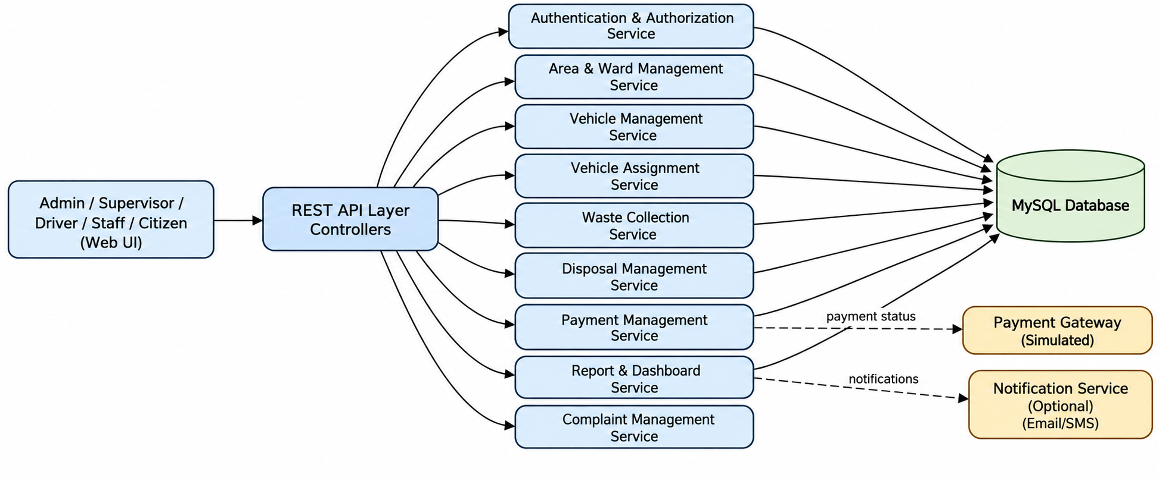
The system is designed as a layered modular monolith: Presentation/UI → REST API/Controllers → Business Services → Data Access/MySQL, with payment and notification/audit adapters.

3.4 Component Descriptions
Component | Responsibilities
Web UI | Login, dashboard, vehicle/area screens, assignment, collection, disposal, payment, complaints and reports.
API / Controllers | Validate request shape, authenticate requests, call services and return standardized HTTP/JSON responses.
Authentication & Authorization | Login, password verification, session/token handling and RBAC for Admin/Supervisor/Worker/Citizen.
Vehicle & Area Service | Vehicle master data, vehicle status and collection-area/ward management.
Assignment Service | Assign vehicle/staff to an area, date and shift; validate assignment conflicts.
Collection Service | Record waste type, quantity, collection time/status and link collection to an assignment.
Disposal Service | Manage disposal sites, capacity, waste-to-site assignment and disposal status.
Payment Service | Calculate/record configured service payment and maintain payment status; uses simulator if applicable.
Complaint Service | Create and update citizen collection complaints/requests and their status.
Reporting Service | Dashboard aggregates and operational reports by date, area, vehicle and payment/disposal status.
Audit Service | Internal logging support for security-relevant and state-changing operations.
MySQL Database | Persistent storage with primary/foreign keys, constraints and transaction support.
Payment Simulator | Returns configurable success/failure for deterministic project testing.

3.5 Chosen Architecture Pattern and Rationale
A layered modular-monolith architecture is selected. It separates UI/API, business logic and persistence while keeping deployment simple for a two-day course project. A microservices architecture is not selected because independent deployment, service discovery, distributed transactions and operational overhead are unnecessary for the expected scale.

3.6 Technology Stack & Data Stores
Layer | Recommended Technology | Purpose
Frontend | React or HTML/CSS/JavaScript | Responsive web UI.
Backend | Node.js + Express (or approved equivalent) | REST API and business logic.
Database | MySQL 8.x | Users, vehicles, areas, assignments, collections, disposal, payments, complaints and audit logs.
Authentication | Session or JWT + bcrypt/Argon2 | Secure account authentication.
API Testing | Postman | Manual API verification.
Version Control | Git/GitHub | Source control and collaboration.

3.7 Data Model / Main Entities
Entity | Key Fields / Relationships
User | user_id, name, email, mobile, password_hash, role, created_at.
Vehicle | vehicle_id, registration_no, vehicle_type, capacity, status, created_at.
Area | area_id, name, ward_code, description, active.
Assignment | assignment_id, vehicle_id, worker_id, area_id, date, shift, status.
Collection | collection_id, assignment_id, waste_type, quantity, collected_at, status.
DisposalSite | site_id, name, location_text, capacity, available_capacity, active.
DisposalRecord | disposal_id, collection_id, site_id, quantity, disposed_at, status.
Payment | payment_id, collection_id, amount, method, status, reference, created_at.
Complaint | complaint_id, user_id, area_id, description, status, created_at, resolved_at.
AuditLog | audit_id, actor_user_id, action, entity_type, entity_id, timestamp.

3.8 Risks & Mitigations
Risk | Mitigation
Two assignments use the same vehicle/worker/shift | Validate availability in the service layer and add appropriate DB constraints.
Disposal quantity exceeds site capacity | Perform server-side capacity validation inside the disposal transaction.
Unauthorized administrative operation | RBAC middleware on every protected admin/supervisor route plus server-side authorization.
Invalid/corrupt master data | Input validation, foreign-key constraints and deactivation instead of destructive deletion where referenced.
API/database failure during collection or payment | Return safe error; use transactions so partial operational records are not committed.
Payment succeeds but record save fails | Use explicit payment states and reconciliation/retry handling appropriate to the simulator.
Scope expansion | Freeze SRS baseline and classify new features as future enhancements.

3.9 Traceability to Requirements
Requirement Area | Design Components
WMS-F-001..002 | Auth Controller + Auth Service + User Repository + RBAC middleware
WMS-F-003..004 | Vehicle Controller + Vehicle Service + Vehicle Repository
WMS-F-005 | Area Controller + Area Service + Area Repository
WMS-F-006 | Assignment Controller + Assignment Service + Vehicle/Area/Worker repositories
WMS-F-007..008 | Collection Controller + Collection Service + Assignment validation
WMS-F-009..011 | Disposal Controller + Disposal Service + Capacity validation + DB transaction
WMS-F-012..013 | Payment Controller + Payment Service + Payment Simulator
WMS-F-014..015 | Reporting Controller + Reporting Service + aggregate queries
WMS-NFR-001..005 | API, DB indexing, transaction strategy, validation, UI and security middleware
WMS-SR-001..005 | Authentication, RBAC, TLS, input validation and authorization middleware

3.10 Security Architecture
Security is implemented through authentication, RBAC, password hashing, parameterized SQL/ORM queries, input validation, authorization checks, HTTPS in deployment, secure session/token handling and audit logging. Sensitive values such as passwords and authentication tokens are excluded from application logs.

4. Design

4.1 Design Overview
Each request follows: UI → Controller → Service → Repository/External Adapter → Database or simulator → Service → Controller → UI. Business rules remain in services rather than controllers, while database operations remain in repositories/DAOs.

4.2 UML Sequence Diagrams
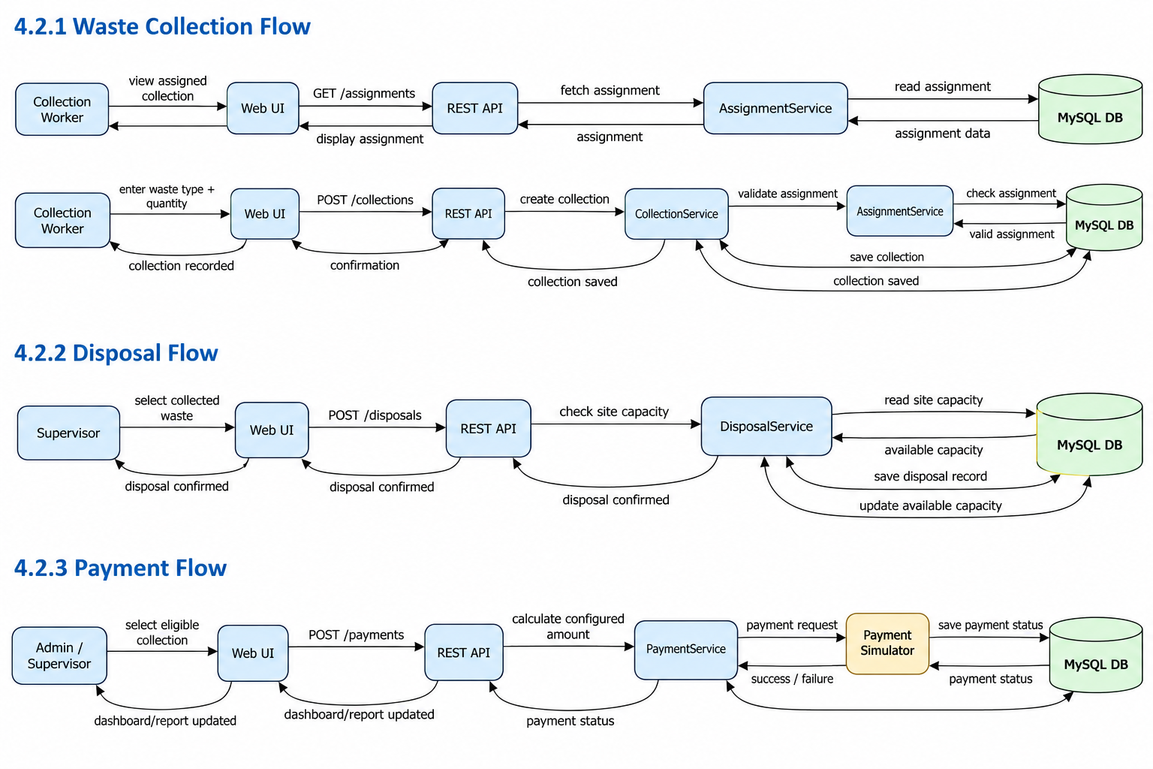

4.3 API Design
Endpoint | Method | Request | Response / Errors
/api/auth/login | POST | email,password | 200 session/token; 401 invalid credentials
/api/vehicles | GET | filters optional | 200 vehicle list; 401/403 unauthorized
/api/vehicles | POST | vehicle data | 201 vehicle; 400 validation
/api/areas | GET | optional filters | 200 area list
/api/assignments | POST | vehicleId,workerId,areaId,date,shift | 201 assignment; 400 validation; 409 conflict
/api/collections | POST | assignmentId,wasteType,quantity | 201 collection; 400 validation; 409 invalid assignment
/api/disposal-sites | GET | optional filters | 200 site list
/api/disposals | POST | collectionId,siteId,quantity | 201 disposal; 400 validation; 409 capacity conflict
/api/payments | POST | collectionId,amount,method | 201 payment; 400 validation; 409 conflict
/api/reports/summary | GET | date/area optional | 200 dashboard/report data; 401/403
/api/complaints | POST | areaId,description | 201 complaint; 400 validation
/api/complaints/{id} | PUT | status/resolution | 200 updated; 403 unauthorized

4.4 Error Handling, Logging & Monitoring
- Use consistent JSON errors: {code, message, details?}.
- HTTP 400 validation, 401 unauthenticated, 403 unauthorized, 404 missing, 409 business conflict, 500 unexpected server error.
- Do not expose SQL statements, passwords, tokens or stack traces to users.
- Log timestamp, severity, request/correlation ID, endpoint and safe error code.
- Track assignment conflicts, disposal-capacity failures, payment failures, collection failures, API latency and authentication failures.

4.5 UX Design
- Dashboard presents the most important operational counts without requiring complex navigation.
- Assignment screen validates vehicle/worker availability before submission.
- Collection form keeps waste type and quantity entry simple and validates non-negative quantity.
- Disposal screen clearly displays available capacity before confirmation.
- Payment screen clearly displays amount and payment status before final confirmation.
- Admin screens use confirmations for state-changing operations.

4.6 Architecture Decision Records (ADRs)
ADR | Decision | Rationale | Alternatives Rejected
ADR-001 | Layered modular monolith | Simple deployment and clear separation for a mini-project. | Microservices: unnecessary operational overhead.
ADR-002 | MySQL as system of record | Waste operations are relational and need foreign keys/transactions. | NoSQL: unnecessary for core transactional data.
ADR-003 | Payment simulator | Allows deterministic testing without real financial transactions. | Real payment gateway: unsafe/out of scope.
ADR-004 | Server-side assignment/capacity validation | Prevents inconsistent assignments and over-capacity disposal. | Client-only validation: bypassable and unreliable.

4.7 Open Issues & Next Steps
- Finalize exact technology versions and deployment environment.
- Seed realistic but fictional vehicles, areas, staff, waste records and disposal sites.
- Confirm the configured payment calculation/rules used in the demo.
- Implement the baseline workflow before optional enhancements.
- Future: live GPS/Maps integration, route optimization, real payment gateway, SMS/email notifications and advanced analytics.

5. Appendices

5.1 Glossary
WMS, RBAC, API, DTO, REST, UAT, RTM, NFR, ADR, CRUD.

5.2 References
City Waste Management System SRS v1.0; City Waste Management System Software Test Plan v1.0; project-approved database/API documentation.

5.3 Tools
draw.io / PlantUML / Graphviz for UML, Postman for API testing, Git/GitHub for version control, MySQL for database design.

